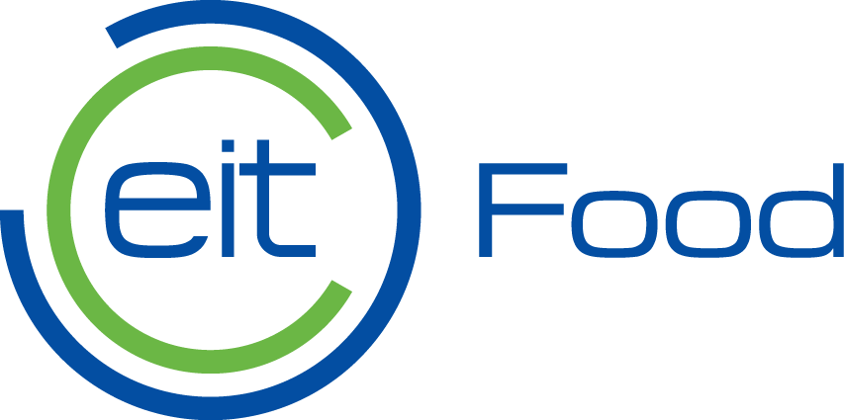

EIT Food – Application form

Cross-KIC New European Bauhaus Call for Regions/cities:
capitalise on existing EIT Food consumer engagement projects

LEAD ORGANISTION SHOULD PROVIDE:

Lead Organisation information

Provide the following information about your organisation.
Official name of Organisation/Agency
Official name in English
Website
Contact address
Street address
City
State/Province/Region
Postal/ZIP code
Country

Co-Organisation information (if applicable)

Provide the following information about your organisation.
Official name of Organisation/Agency
Official name in English
Website
Contact address
Street address
City
State/Province/Region

Project Lead

Provide the name of the person leading the application and the respective contact details.
First name
Surname
Title (e.g. Director, Head)
Department
Phone | (+ country code)
E-mail

Project Coordinator

Designate a contact person from the region, city or entity with a legal link to the cities to the project. The availability would be ca. 8h per week during the project duration to act as a “virtual client” and as coordinator of the activities.
First name
Surname
Position
Phone | (+ country code)
E-mail
  - Project, planning and impact
Please define the project, including timeline, funding, key partners, and specific issues or challenges related to the project. Please also provide a description of the connection to the agri-food community in the target city, and the envisioned impact of the project for the city.
(Limit your response to 500 to 600 words.)
<Write here>
  - Organisation and Team
Please provide a brief description of your organisation and its main activities and provide details of the team members and experts, including workshop moderators, who will be involved in the activities of EIT Food NEB Consumer Engagement Lab (please provide name and short profile, indicating relevant experiences related to managing/coordinate/moderating/facilitating citizens sessions such as: focus group interviews, consumer panels, social labs, co-creation workshops, creativity sessions).
<Write here>
  - Citizen engagement project experience
Please provide examples of the relevant activities/services/projects implemented by your organisation that involved qualitative consumer or citizen studies (such as: focus group interviews, consumer panels, social labs, co-creation workshops, creativity sessions) and justify, why they are meaningful for EIT Food NEB Consumer Engagement Labs.
<Write here>

  - Visibility
Please indicate what resources will be available for local animation and dissemination of the project activities. Please describe how you plan to promote the Labs in local media (printed press or magazines) to ensure 1 non-paid publications in the local language about the activities before the end of 2021.

<Write here>

  - Budget
Please provide an indicative budget table including eligible cost categories specified in the call text. Total costs mustn’t be higher than 30.000€

<Write here>

Date: Signature Project Lead :

Please send your filled in application in one single PDF file before 18 July 2021 to: clcwest@eitfood.eu

