EIT Food is supported by the EIT
a body of the European Union

2022 Innovation Call for Proposals

Criticality Map

EIT Food
07 October 2021

The criticality of each technology should be assessed by the consortium using the following scale 1 to 3:
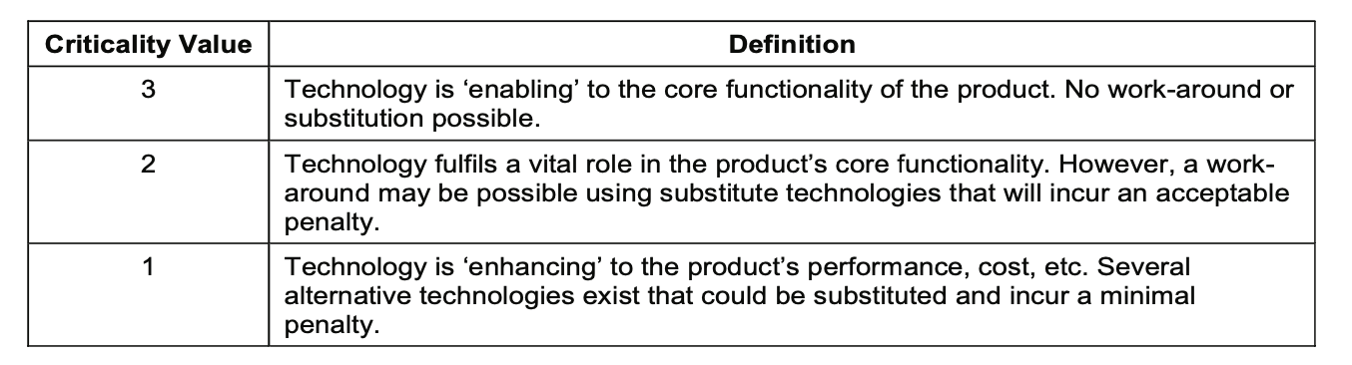
Field Name | Critical/Core Technology
Content Type | table
Help | Please indicate each individual critical/core technology composing the innovative solution.
Technology | TRL Level | Criticality Level (1/2/3) | Please justify the critical/core technology level according to the definition provided.  - You mentioned some technologies are critital, why?  - You mentioned some technologies are not critical, why?

