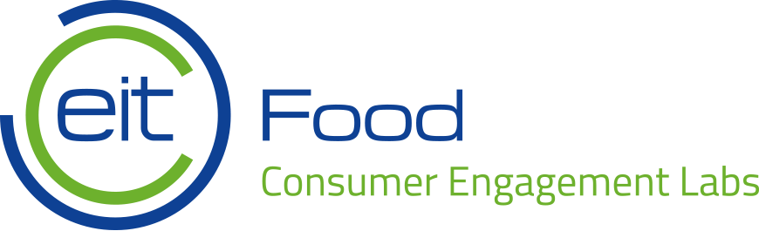

EIT Food RIS Consumer Engagement Labs Application Form
Please fill in the application form, ensuring that all fields are completed, including signatures of legal representatives of applicant organisations. Please submit the set of applications from 3 organisations in the consortium/innovation network in electronic format (PDF) by
11 September 2020, 3 pm CET to email address: mzatorska@wz.uw.edu.pl. Applications that are incomplete or sent after the deadline will be rejected. Please do not provide further supporting documents and limit your application to presenting all information required by this form.

EIT Food RIS Consumer Engagement Labs Application Form
Consortium member 1: scientific organisation (higher education or public research institute)
1. Country
2. Name of the applicant organisation
3. Legal form
4. Office address (street, city, country)
5. Website address
6. Contact person
7. Position
8. E-mail
9. Phone
10. Please provide examples of the relevant activities/services/projects implemented by your organisation that involved qualitative consumer or citizen studies (such as: focus group interviews, consumer panels, social labs, co-creation workshops, creativity sessions) and justify, why they are meaningful for EIT Food RIS Consumer Engagement Labs.
11. Please provide details of 3 experts - workshop moderators who will be involved in the activities of EIT Food RIS Consumer Engagement Labs (please provide name and short profile, indicating relevant experiences related to moderating/facilitating group sessions such as: focus group interviews, consumer panels, social labs, co-creation workshops, creativity sessions).
Expert 1:

Expert 2:

Expert 3:

12. Scientific organisation involved in the EIT Food RIS Consumer Engagement Labs will need to use online video conferencing software Zoom to deliver the Labs session, leveraging the Zoom breakout rooms functionality (with 3 teams of approximately 5 participants, and plenary meetings of about 15 consumers and observers). The costs of using Zoom platform will not be additionally reimbursed by EIT Food (but only one Zoom license will be required for a period of ~2 weeks). Please briefly describe your experiences with using video conferencing software to run workshops, research projects, organisational meetings or educational activities.
13. RIS Consumer Engagement Labs workshop should be organized in October-November 2020, and consist of 10 online meetings distributed over a period of 2 weeks. The recommended timeline includes sessions on Tuesdays, Wednesday and Thursdays, separated by intervals for additional teamwork between Friday and Monday each week. Prior to session 1 of the workshop, you will need to promote the project among potential applicant, ensure recruitment of a group of consumers meeting detailed selection criteria, prepare local translations of Labs materials used in workshops and meet the requirements including workshop logistics and recording of the sessions. Workshop dates should not overlap with national or religious holidays, elections, or other foreseeable events disrupting the creative process. Please provide preliminary proposal of workshop dates:
-workshop session 1:
-final workshop session (two weeks after session 1):

By submitting this application form, I confirm that the information provided above correctly represents the scope of activities and plans of my organisation. I understand that the information provided in this form may be used to define obligations in subcontracting agreement. I give consent to processing the application by EIT Food, its Co-Location Centres, University of Warsaw and external experts involved in the evaluation process, and am willing to cooperate to provide further information or documents confirming the facts presented above.
If selected, I declare the willingness to promptly proceed to sign the subcontract agreement with EIT Food based on the template published online by EIT Food as part of the call documentation. I will act as subcontractor in EIT Food RIS Consumer Engagement Labs in 2020 based on conditions described in the “Call for expression of interest to participate in EIT Food RIS Consumer Engagement Labs”. I am aware of the scope of services that should be provided and confirm having familiarized myself with the contents of the „Call for expressions of interest to participate in EIT Food RIS Consumer Engagement Labs”, subcontract agreement and excerpts from EIT Food Framework Partnership Agreement, published online by EIT Food as part of the call documentation.
I understand that my subcontracting agreement can only enter into force if all three members of the consortium, jointly submitting the application, confirm their participation in EIT Food RIS Consumer Engagement Labs by signing their subcontracting agreements.

Date, place ……………………………………………………………………
Name of the person submitting the application ……………………………………………………………………
Organisation submitting the application ……………………………………………………………………

EIT Food RIS Consumer Engagement Labs Application Form
Consortium member 2: food producer
1. Country
2. Name of the applicant organisation
3. Legal form
4. Office address (street, city, country)
5. Website address
6. Contact person
7. Position
8. E-mail
9. Phone
10. Please identify a specific category of food products that co-creation workshops in your country would focus on. Justify why the creative work of a group of consumers on identifying new food product concepts in this product category could be meaningful for EIT Food RIS Consumer Engagement Labs project and also beneficial for senior consumers in your country.
11. Food producer involved in the EIT Food RIS Consumer Engagement Labs will need to commercialise one new product resulting from the Labs session in 2021. Please explain your motivation to deliver food innovations targeting senior consumers.
12. Please describe how you plan to promote the Labs in local media (printed press or magazines) to ensure 2 non-paid publications in the local language about the Labs before the end of 2020.

By submitting this application form, I confirm that the information provided above correctly represents the scope of activities and plans of my organisation. I understand that the information provided in this form may be used to define obligations in subcontracting agreement. I give consent to processing the application by EIT Food, its Co-Location Centres, University of Warsaw and external experts involved in the evaluation process, and am willing to cooperate to provide further information or documents confirming the facts presented above.
If selected, I declare the willingness to promptly proceed to sign the subcontract agreement with EIT Food based on the template published online by EIT Food as part of the call documentation. I will act as subcontractor in EIT Food RIS Consumer Engagement Labs in 2020 based on conditions described in the “Call for expression of interest to participate in EIT Food RIS Consumer Engagement Labs”. I am aware of the scope of services that should be provided and confirm having familiarized myself with the contents of the „Call for expressions of interest to participate in EIT Food RIS Consumer Engagement Labs”, subcontract agreement and excerpts from EIT Food Framework Partnership Agreement, published online by EIT Food as part of the call documentation.
I understand that my subcontracting agreement can only enter into force if all three members of the consortium, jointly submitting the application, confirm their participation in EIT Food RIS Consumer Engagement Labs by signing their subcontracting agreements.

Date, place ……………………………………………………………………
Name of the person submitting the application ……………………………………………………………………
Organisation submitting the application ……………………………………………………………………

