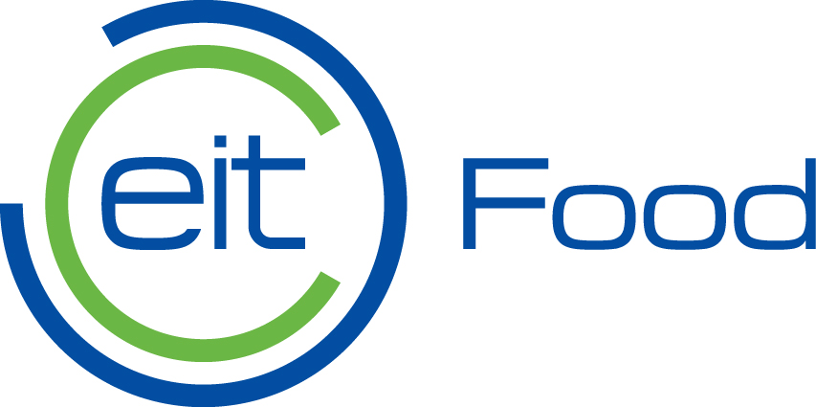

2024 Fast Track to Market

Request for Applications

Application Form

Leuven, Belgium
February 2024

Eitfood.eu

NOTE:
This form is provided to companies applying for the 2024 Fast Track to Market Initiative. Applications will only be evaluated if all required documentation has been submitted alongside this form via email to FastTrackCall@eitfood.eu no later than 10 April 2024 – 12.00 noon CET. The title of the email subject should begin “Application Submission: 2024 Fast Track to Market”.

EIT Food is not responsible for a negative outcome of the evaluation due to missing, outdated or incorrect information.

TERMS AND CONDITIONS
Requested | Acceptance of Terms and Conditions
Requirement | I confirm that the information in this application form is accurate and that none of the funded fast-track-to-market project activities were started before the proposal was submitted.  I declare myself fully compliant with the eligibility criteria set out in the guidelines.  I declare I have the financial and operational capacity to implement the fast-track-to-market project. | Please select:
 |  | ☐
COMPANY NAME
Field Name | Name of your company
Content Type | Free text (max 140 characters)
Help | Please enter the name of your company in the box below.
Content
COMPANY PRESENTATION
Requested | Company Business Plan & Presentation
Content Type | Attachment in PDF (Word or PPT only in free format)
Requirement | The Business Plan & Presentation should cover your company’s commercial history and success.  The contents should convince EIT Food of the maturity and suitability of your company to lead the Fast Track to Market project.  The content of your company Business Plan & Presentation should, therefore, demonstrate, at a minimum:  - The company’s overall strategy and objectives, including alignment with EIT Food’s missions,  - An updated business model description, including a business model canvas,  - The right and combined set of expertise, including commercial competencies at the CxO level.
FAST-TRACKED PRODUCT/SERVICE
Requested | Fast-Track Pitch Deck
Content Type | Attachment in PDF (Word or PPT only in free format)
Requirement | This Fast Track Pitch Deck should cover the proposed technological solution.  The contents should convince EIT Food of the readiness and appropriateness of the proposed solution for fast market entry.  Your attachment should, therefore, demonstrate, at a minimum:  - The maturity of your business case to accelerate and generate sales within ten months,  - The feasibility and appropriateness of your solution in successfully addressing the needs of the identified market and one or more of EIT Food’s missions (incl. key proof points such as figures to justify a Product-Market Fit, a well-defined Value Proposition, an analysis of your Key Exploitable Results, etc.),  - How your intellectual property strategy (e.g., patents filed or secured) and safeguarded know-how and expertise are granting you a license to operate and scale.
COMMERCIALISATION STRATEGY
Requested | Commercialisation Plan
Content Type | Attachment in PDF (Word or PPT only in free format)
Requirement | This commercialisation plan should cover all your company's current and future assets/products.  The contents must convince EIT Food of your company’s commercial awareness, capacity, and B2B/B2C abilities to generate revenues for your entire product portfolio, including the fast-tracked solution.  Your attachment should, therefore, include, at a minimum:  - Valid and realistic assumptions and robust forecasting models,  - Elaborations on market entry, customer segmentation, and your value proposition,  - Analysis of the total addressable market, the growth potential, and the level of competition present,  - A convincing risk analysis of external forces and trends that might impact the business model, mitigation actions, and how the company aims to use favourable market conditions,  - Any document indicating off-taker support, e.g. signed partnership agreements, letters of intent or purchase orders within the past 12 months.
FINANCIAL MATURITY
Requested | Verified Financial Report
Content Type | Attachment in PDF (in free format)
Requirement | The documents should provide a detailed calculation of the expected costs and revenues covered during the potential 4-year repayment period of the RBF scheme.  The contents should convince EIT Food of your financial health, revenue-generating potential, and current funding gap for market entry.  The financial statement over the past two years and assumptions for the next four years should include, at a minimum:  - Assumptions sheet,  - Balance sheet,  - Income statement (incl. forecasts),  - Cash flow statement,  - Statement of shareholders’ equity (CAP table).
PROJECT PLAN
Requested | Project Plan
Content Type | Free text: Please write your Project Plan in the Content Box below.
Requirement | The project plan should cover the entire duration of the project.  It should convince EIT Food that your post-trial completion and consumer marketing activities and schedule are clear, coherent, and feasible.  Your attachment should, therefore, demonstrate, at a minimum:  - The project’s objectives and sequential work packages with crucial project activities well-presented in a timeline,  - Means of verification (i.e., how do you intend to prove to EIT Food that a milestone has been reached? If helpful, you can refer to your OKR’s),  - Your plan to reach the following KPIs and deliverables, expected of selected applicants at the completion of the project:  - KPI: marketed innovation  - DEL 1: a Commercial agreement  - DEL 2: a final Communication and Dissemination report  - DEL 3: a final technical and commercial report  - A post-project action plan that outlines how you intend to lead follow-up sales activities for the fast-tracked solution,  - If not already detailed in your commercialisation plan, the identified status of the commercialisation activity for the fast-tracked solution, including key risks registered and corresponding mitigation plans, pending actions, impediments, and timeline.
Content | Project Plan:
BUDGET PLAN
Requested | Budget Plan
Content Type | Attachment in Excel (in free format)
Requirement | The budget plan should cover the project costs for all parties involved and the funding needed for the SME, as the sole subgrant recipient, to implement the project. The contents must convince EIT Food that the cost estimates are adequate and realistic.  Your attachment should, therefore, include, at a minimum:  - A breakdown of the project costs, other relevant costs, and the amount of EIT Food funding requested,  - A justification and explanation of the cost estimates and funding request based on background assumptions,  - A view of how the project costs are aligned with project milestones, to facilitate a value-for-money assessment.

