EIT Food press kit

Within this press kit, you will find useful information, links and messaging about EIT Food.

Contents
- About EIT Food
- EIT Food press releases and logos
- The EIT Food missions
- EIT Food spokespeople

About EIT Food

EIT Food is the world’s largest and most dynamic food innovation community. We accelerate innovation to build a future-fit food system that produces healthy and sustainable food for all. ​

Supported by the European Institute of Innovation and Technology (EIT), a body of the European Union, we invest in projects, organisations and individuals that share our goals for a healthy and sustainable food system. We unlock innovation potential in businesses and universities and create and scale agrifood startups to bring new technologies and products to market. We equip entrepreneurs and professionals with the skills needed to transform the food system and put consumers at the heart of our work, helping build trust by reconnecting them to the origins of their food.

We are one of nine innovation communities established by the European Institute for Innovation & Technology (EIT), an independent EU body set up in 2008 to drive innovation and entrepreneurship across Europe.

Find out more at www.eitfood.eu or follow us via social media: X (formerly Twitter), Facebook, LinkedIn, YouTube and Instagram.

EIT Food press releases and logos

All press releases and news announcements from EIT Food can be found online here. For more information, please contact: communication@eitfood.eu

EIT Food logos and brand guidelines can be accessed and downloaded here.

The EIT Food missions

EIT Food is addressing the complex and critical challenges of sustainability and climate change, of non-communicable diseases and poor nutrition, and of consumer trust, scarcity and transparency. Through our Missions-led approach, together with our community we will make a material difference to health adjusted life years by enabling more consumers to make better choices through access to healthier products and actionable information. We will be closer to a net zero food system, reducing CO2 equivalent emissions by tackling CO2 hotspots, reducing the footprint of proteins through diversification, and creating new markets for food waste. And we will see the benefits of more resilient, trusted food supply chains with people experiencing greater food security and safety through widespread digitally enabled food supply chains. Find out more here.

Our three mission areas are:

- Healthier Lives Through Food: Nutritious, diverse food choices can benefit people and planet, but challenges in affordability, profitability and lack of awareness means unhealthy food products are often favoured by both industry and consumers. To increase the uptake of balanced, sustainable and healthy diets, we need greater levels of awareness about the relationship between nutrition and health, increased support for innovative solutions for affordable products, and policy interventions that prioritise soil health, nutrition and food education. Find out more here.
- A Net Zero Food System: The food system is responsible for almost a third of greenhouse gas emissions, with connected challenges such as food waste, resource depletion and energy consumption. To reach net zero and mitigate the impacts of the climate crisis, we must scale a systems approach to change that enables the transition to sustainable and regenerative agriculture practices, creates new markets and opportunities for food waste and loss reduction, and empowers all stakeholders to play an active role in the circular food economy. Find out more here.
- Reducing Risk for a Fair and Resilient Food System: The current food system is vulnerable to external shocks, putting stakeholders across the entire value chain at risk. To reduce this risk and increase food security and safety for consumers everywhere, at all times, we must collaborate to enable fairer, more resilient and transparent food supply chains that are rooted in innovation and equitable business models. Find out more here.

EIT Food spokespeople

Spokesperson | Headshot | Biography
Dr Andy Zynga, CEO of EIT Food | 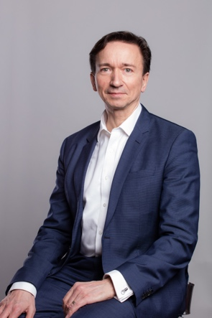 | Dr Andy Zynga is the CEO of EIT Food, the world’s largest food innovation community working to build a future-fit food system that produces healthy and sustainable food for all. Based in Leuven, Andy has international experience in food systems, innovation, telecoms and technology services and a proven track record of building profitable businesses in the USA and Europe.
Saskia Nuijten, Chief Brand & Communications Officer at EIT Food | 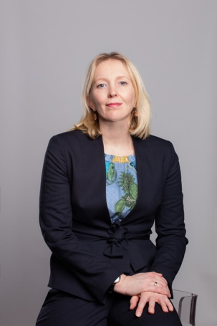 | Saskia Nuijten is part of the Executive Management Board of EIT Food and leads Corporate Communication.

