Company name of sending partner company
PROJECT MEDIA RELEASE
Street
Postal code, City

Place, Date

Title

<Introduction paragraph, use this letter font and size>

<Body text, use this letter font, can be several paragraphs>

For more information, please contact:
<Name and contact person of project member dealing with media questions>

About EIT Food
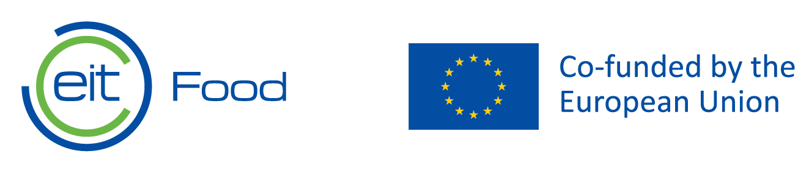
<Project name> is a project under the support of EIT Food. EIT Food is the world’s largest and most dynamic food innovation community. We accelerate innovation to build a future-fit food system that produces healthy and sustainable food for all.
Supported by the European Institute of Innovation and Technology (EIT), a body of the European Union, we invest in projects, organisations and individuals that share our goals for a healthy and sustainable food system. We unlock innovation potential in businesses and universities, and create and scale agrifood startups to bring new technologies and products to market. We equip entrepreneurs and professionals with the skills needed to transform the food system and put consumers at the heart of our work, helping build trust by reconnecting them to the origins of their food.
We are one of eight innovation communities established by the European Institute for Innovation & Technology (EIT), an independent EU body set up in 2008 to drive innovation and entrepreneurship across Europe.
Find out more at www.eitfood.eu or follow us via social media: Twitter, Facebook, LinkedIn, YouTube and Instagram.
About ….
<Here you can include a short note on the partner companies and/or on the project – please make this no more than 150 words>

