# EIT Food Launch Plan Template and Succes Sharing Mechanism

**INSTRUCTIONS:**

The following template serves as a guide for you to provide EIT Food evaluators with two required components of the proposal application, (1) a Launch Plan and (2) a Success Sharing Mechanism table. Note that both components are mandatory for commercial proposals.

The Launch Plan (including the Success Sharing Mechanism Table) and any supporting documents you wish to share **must be uploaded as a single PDF document with your application.** Please consider a page limit of 10 pages or 20 slides.

1. **A Launch Plan**

Please provide a launch plan that demonstrates your ability to build commercial value from new intellectual property (IP) or bring innovations to the market and at scale.

Feel free to share your existing business plan materials with us, use your own layout, include figures, and modify the proposed structure to fit your story. The information will be evaluated based on its content, completeness, level of detail and credibility.

The chapters and sections below can be used as guidance to ensure you include the most critical components of the commercialisation strategy.

If there are more exploiting parties in the consortium, it is advised to prepare the commercialisation/launch strategy per exploiting party.

1. **Success Sharing Mechanism**

The EIT Food 2023-2025 Success Sharing Mechanism spans 3 phases and is outlined in the [Funding Framework Guidelines](https://www.eitfood.eu/open-calls/impact-funding-framework) and Annex C below.

Phases 2 and 3 of the mechanism are proposed by the exploiting party(ies).

Please describe the proposed Success Sharing Mechanism and include the table below in your commercialisation/launch strategy document.

***Note that completing the table is mandatory.***

|  |  |  |  |  |  |
| --- | --- | --- | --- | --- | --- |
| **Phase** | **Identifier** | **Description** | **Percentage** | **Amount** | **Expected timing** |
| 1 | Payment month 3 | Fixed | 10% | € | QX 202X |
|  | Payment month 15 | Fixed | 20% | € | QX 202X |
| 2 | Success contribution Milestone 1 | …. | X% | € | QX 202X |
|  | Success contribution Milestone 2 | …. | X% | € | QX 202X |
|  | Success contribution Milestone X | …. | X% | € | QX 202X |
| **3** | *The mechanism for this phase can be based on pre-defined milestones, equity, revenue sharing, or royalties, among others.* | | | € | QX 202X |

# Launch Plan Guide

**SUMMARY**

*Please provide a concise overview of your Launch Plan, highlighting key points such as the IP or innovation’s value proposition, target markets and customers, financials, key partners and activities. You may use the* [*Business Model Canvas*](https://eitfoodivzw.sharepoint.com/sites/MissionProgrammes-RequestforContributors-MissionsTEAM/Freigegebene%20Dokumente/Missions%20TEAM%20-%20General%20Comms/Funding%20Framework%202023-25/eitfood.eu/files/Business-Model-Canvas-template-1.pptx) *as a structure (either in descriptions or as a figure).*

**COMMERCIAL PRODUCT/SERVICE AND BUSINESS MODEL**

*Please summarize product/service offering(s) and the intended business model(s) that will generate the projected revenues of the Key Exploitable Result(s). Include your value proposition, pricing and demonstrate/argument customers “willingness to pay”.*

**MARKET AND CUSTOMERS**

* *Market Size and Growth: Outline the current size of the target market and its projected growth over the next few years. It is advised to use the TAM, SAM, SOM methodology (see Annex B).*
* *Market trends: Highlight key trends, shifts, and dynamics in the industry that support the need for your product/service.*
* *Target customer: Define your target customer segments and their characteristics. You may also explain which customer groups you are not targeting.*
* *Market entry and channels: Explain how you will reach and convince your first and subsequent customers and how you will ensure repeating business.*
* *Competitive Landscape: Identify key competitors, their strengths and weaknesses, and your differentiators.*

**ROADMAP FOR THE COMMERCIALISATION/LAUNCH**

* *Road-to-market: Provide a detailed timeline and action plan towards launching the innovation to the market. Please use milestones to indicate the expected progress. Milestones can cover all aspects of the business including technical (development), regulatory, commercial, operational, manufacturing etc. (see Annex A). You may also refer to Technology or Market Readiness levels when describing the roadmap for commercialisation.*
* *Scaling-up: Provide a scale-up plan for the first 3-5 years of commercialisation. Again, you can use milestones to plan the expected progress towards success. You can use the same milestones in the Success Sharing Mechanism.*
* *Key partners and collaborators: Describe key partners (e.g. along the value and supply chains) that are critical to successful commercialisation of your innovation. Please describe your current business relation with them.*
* *Risk mitigation: Identify potential risks that could affect the success of your commercialization strategy and outline steps you'll take to mitigate them. Please do think beyond technical risks.*

**FINANCIAL PROJECTIONS**

* *Revenue Projections: Estimate your expected sales and revenue over the next few years. Please include your assumptions and references to improve the credibility of the projections.*
* *Cost Structure: Break down your fixed and variable costs related to production, marketing, distribution, and other operational expenses.*
* *Profitability Analysis: Provide insights into when you expect to achieve profitability and the factors driving profitability.*
* *Cash Flow Projection: Illustrate your expected cash inflows and outflows, demonstrating your ability to manage financial resources. If you are not profitable from the start, please explain how you will bridge a potential funding gap.*

**INTELLECTUAL PROPERTY STRATEGY**

* *Protection: Detail your intellectual property protection strategy, including patents, trademarks, copyrights, or trade secrets.*
* *Freedom-to-operate: Please explain your freedom to operate and whether there is any blocking IP.*
* *IP within the consortium: Please explain ownership and utilization of IP across the consortium.*

# ANNEX A - USING MILESTONES

When describing the **roadmap for the commercialization/launch** it is advised to use key milestones that represent a feasible commercial growth path (scale up pace) for each exploitable result in the foreseeable future. Please provide in which quarters and calendar year certain milestones of each Key Exploitable Result (KER) are planned. Examples of milestones are:

* Key Exploitable Result is fully developed and ready for market entry (e.g., Technology Readiness Level 9)
* Supplier or offtake agreements are signed
* First commercial scale production plant established
* First sale
* A certain threshold in sales volumes is reached
* A certain number of customers
* Financial break-even point is reached (i.e., costs for development and market introduction of Key Exploitable Results are paid back by sales of the KER)
* Market introduction in certain (new) countries
* First sale to a new type of customers

# ANNEX B - GUIDANCE FOR MARKET SIZE INDICATIONS

**Example**

Problem:

Water shortage and food supply in danger. Young trees that are cultured (seedlings) in developing countries need to grow to a point at which they can provide fruits, nuts etc.

Key Exploitable Result:

Casing around tree to catch water vamp for irrigation.



**Total Addressable Market (TAM):**

Total worldwide coastal irrigation market for all types of young trees (food and non-food) with imminent water stress (EUR 3.1 bln)

**Serviceable Available Market (SAM):**

Total coastal fruit, nut and olive tree irrigation market with imminent water stress (EUR 1.4 bln)

**Serviceable Obtainable Market (SOM):**

Portuguese and South-African fruit, nut and olive trees (EUR 70 mln)

# ANNEX C - SUCCESS SHARING MECHANISM

In line with the EIT Food Financial Sustainability Strategy and EIT requirements, all activities selected for funding intended to produce commercial outcomes are required to commit to sharing commercial successes with EIT Food. Selected activities must comply with Success Sharing Mechanism for Business Plan 2023-2025.

The 2023-2025 Success Sharing Mechanism spans 3 phases corresponding to the progress of market uptake of the proposed innovation (see below). As depicted in the illustration below, the Success Sharing Mechanism enters into force at the completion date of the EIT Food funded activity (as defined in the original proposal and agreed upon by EIT Food), with Success Sharing contributions spanning across the different phases. EIT Food will periodically monitor the progress of commercialisation to track the progress within each phase.

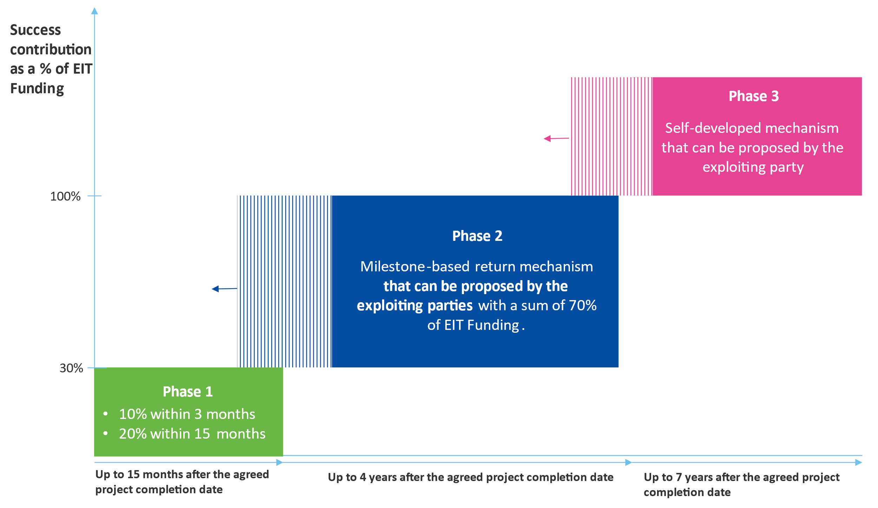

**Phase 1 - Market Entry:** In this phase, we expect exploiting parties to have launched innovations on the market or be nearing market launch. The Success Sharing contribution to EIT Food equals 30% of the awarded EIT Food Funding and must be returned within 15 months after the agreed completion date. The phase 1 contribution is split into 2 tranches:

* A contribution equal to 10% of total EIT Food project funding received by a project consortium must be shared with EIT Food within 3 months following the completion date.
* A contribution equal to 20% of total EIT Food project funding received by a project consortium must be shared with EIT Food within 15 months following the completion date.
* In the case of Collaborative Missions Programme awards, the repayments apply to the commercial project activities contained as discrete work packages within the Programme.
* In case the exploiting party(ies) is unable to fulfil these terms within the 15 months’ timeframe, EIT Food will initiate an IP recovery process in collaboration with the exploiting party(ies) and will look for alternative commercialisation opportunities.

**Note**, the trigger point for Phase 1 is the planned completion date of the projects, as put forward in the proposal. If the project is extended, the original completion date remains the trigger for Phase 1.

**Phase 2 - Scale:** We expect that within 4 years of project completion, consortia will have launched their innovation(s) in the market and are scaling up commercialisation efforts. Consortia are expected to share their commercial successes with EIT Food, following a path of pre-defined milestones, spanning up to 4 years post completion date.

* The exploiting party(ies) propose a credible, measurable, and verifiable set of milestones which are monitored with the EIT Food key account manager throughout this phase. The Success Sharing contributions linked to these proposed milestones must combined amount at minimum to 70% of the total received EIT Funding.
* The exploiting party(ies) define the milestones and corresponding Success Sharing contributions in the commercialisation template attached as supporting document to the proposal application.
* Milestones may be triggered at any point after project completion. If milestones are not met within the expected timeframe, they may roll forward until the end of the Succes Sharing Period, or the KIC may work with the consortium to enhance IP valorisation.

**Phase 3 - Maximize:** Consortia are expected to share in their success up to 7 years after project completion. Because the magnitude of success will differ amongst marketed innovations, we expect the exploiting party(ies) to propose a Success Sharing Mechanism for phase 3 that is proportional to the anticipated commercial success and associated risk. Exploiting party(ies) have full flexibility to propose a structure that fits the planned commercialisation strategy.

* Exploiting party(ies) propose a Success Sharing Mechanism which can be based on pre-defined milestones, equity, revenue sharing, or royalties, among others.
* Exploiting party(ies) define their proposed mechanism at proposal stage. The agreed upon terms and conditions may be renegotiated with EIT Food at the end of Phase 2, upon courtesy of EIT Food.

**Examples of Commercialisation Milestones:**

In order to support applicants through the application process, below are some examples of milestones that can be proposed for Phase 2 and Phase 3. These are for inspiration and other milestones may be proposed as long as they are SMART: Specific, Measurable, Attainable, Relevant, and Time-bound.

* Milestones related to market entry: product launch in new markets, geographies, or segments
* Milestones related to IP: IP protection, IP transfer, or licensing agreements
* Milestones related to operational capacity: production capacity, production volumes, sales teams, etc.
* Milestones related to sales or revenue generated
* Milestones related to financing events: investment rounds, IPO, or loans acquired

**The financial basis for calculating the Success Sharing contribution**

The indicated minimum required contribution will be calculated based on the EIT Food funding budgeted for the entire lifetime of the Activity (project). Any subsequent budget amendment resulting from the monitoring process and approved through the Business Plan Amendment will be taken into consideration.

**Evaluation of the Succes Sharing Mechanism**

The commercialisation strategy and proposed Success Sharing Mechanism are key components of the proposal. Therefore, it is a very important element of the proposal and sufficient efforts must be made at the proposal stage to present a credible, ambitious and competitive contribution to EIT Food, see also the Evaluation Criteria. Compulsory information related to the Success Sharing Mechanism must be completed upon proposal submission and submitted by the ‘exploiting party or parties’ who will commercially exploit the ‘Key Exploitable Result(s)’ that result from the Activity.

**Success Sharing Mechanism Agreement**

The Success Sharing Mechanism will be formalised according to the EIT Food Success Sharing Mechanism Agreement (SSMA) terms and conditions. The SSMA must be agreed to and signed by the exploiting party(ies) and EIT Food **as a mandatory condition for funding.**

The Success Sharing Mechanism distribution will need to be agreed upon amongst the consortium parties. EIT Food encourages and recommends putting in place an internal agreement (ideally in a Consortium Agreement, however the Partners are free to decide the format and document) between consortium partners, defining a fair split of the risks and responsibilities towards exploitation of the project results, Ips and Success Sharing contributions. Agreements with the consortium Parties on the Success Sharing Mechanism will be finalised with EIT Food after proposal selection.

The Success Sharing Mechanism proposed at proposal stage is subject to evaluation and further negotiation throughout the agreement phase.