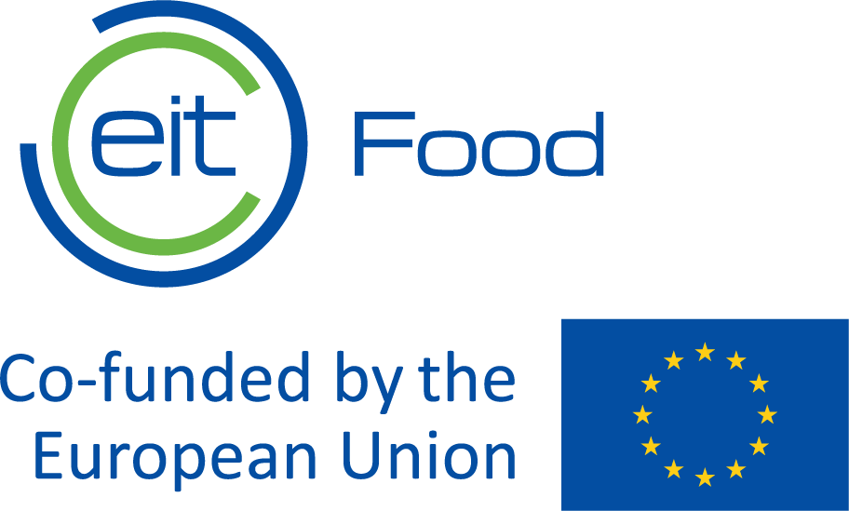
​RIS Straight to Market

Submission Document

Startups/SMEs

If you have any questions during the application process, please check the Call’s webpage or contact us at maria.canelhas@eitfood.eu
The Activity Leader is responsible for completing this submission form. Please read the Call Guidelines carefully.
I have read the Call Guidelines ☐

Individual Organisation (Consortium Member) Eligibility
Please complete the below table for each consortium member.
Name of the Activity Leader | Enter the Name of the Activity Leader
Activity Leader's organisation | Activity Leader's organisation
Email address of the Activity leader | Enter the email address of the Activity Leader.
Name of eligible EU or Horizon Europe country in which this organisation is a legally incorporated entity: | Enter country
Legal form
Office address (street, city, country)
Website address
Contact person
Position
E-mail
Phone
List of documents fulfilled and signed
Application form | ☐
Business model canvas template | ☐
Gantt chart with implementation schedule for Project activities | ☐
Detailed budget breakdown | ☐

Consortium Eligibility
Are you applying in consortia with a retailer? | Yes/No
Name of the startup organisation | Enter name of the organisation you are applying with
Does each member of the consortium have an active role that is commiserate with the level of budget asked? | Yes/No

Proposal Eligibility
Is the goal of this proposed activity to deliver one or more near-to-market, commercially viable innovative technology solutions (goods, services, processes, or products) within 18 months? | Yes/No
Please list which EIT Food Missions you commit to address by bringing to market the new product

Max 3000 characters

Please list which EIT Food Focus Areas you commit to address by bringing to market the new product
Max 3000 characters

Proposal Information
Project executive summary: Briefly summarise the main characteristics of the product you will put into the market and its added value. For successful proposals, this text will be used for public dissemination on the EIT Food website and in its publications.
Max 3000 characters
Please describe what stage of the Market Readiness Level your product is (incluidng MPV)
Max 500 characters

Impact
Project description: Please clearly describe the main features of the new product and its innovative properties

Max 6000 characters

Expected impact on better nutrition, health and/or sustainability provided by the new product Describe the impact of your product on increasing healthy and better nutrition on consumers, according to EIT Food’s Impact Framework goals described in Table 1 of the Call guidelines

Max 3000 characters

Please describe how you will put into the market, how you will produce it, how many units you aim to sell, how you will improve your production processes, ingredients or materials, based on your own market segmentation, according to EIT Food’s Impact Framework goals described in Table 1 of the Call.
Max 6000 characters
Please describe your company’s experiences in designing and introducing new types of for food products, including your approaches to healthier and more sustainable products use of dedicated CAD software, prototyping and manufacturing capabilities. Please refer to the scale of your operations (volumes of sales, composition of product portfolio, number of clients-food service providers, sales revenues).

Max 3000 characters
Please describe how the participation in the project has the potential to improve the production capacity, technology, ingredients, packaging (with exception of changes in branding or packaging visuals), nutritional profile and labelling information, innovative features of a product.

Max 3000 characters

KPIs
Please insert the number you commit to achieve, and describe how you will deliver the following the mandatory KPIs for 2023. The feasibility of achieving the KPIS will be evaluated.

KPI reference | KPI title | KPI description | Target  date | Minimum  Target  Per project | Proposed for 2023
EITHE02.4-EITRIS | EIT RIS Marketed Innovations | Number of all innovations introduced on the market during the programme duration or within 1 year after completion. Innovations include new or significantly improved products (goods or services) sold.  Innovations introduced on the market must be directly linked with the programme and reported in the year when they reached the first revenue (but not later than one year after completion of the programme).  Sales revenue > 10KEUR | 30 June 2024 | 1
Max 5000 characters

EITHE11.1 | FS revenue | Total financing generated in year N (absolute value in EUR). | Up to 15 months after project official end date | According to FRM (section 3.5.3)
Max 5000 characters

EITHE16 | Disseminated results/GP/LL | Continuous dissemination by consortia: number of results, good practice (GP) and lessons learnt (LL) disseminated through appropriate means (e.g., publications, online repositories, fact sheets, targeted workshops). Results are any tangible or intangible output of the action, such as data, knowledge and information. | 1 December 2023 | 1
Max 5000 characters

EITHE17.1 | Reach of KIC’s communication activities: # media coverage | # media articles in the media (articles and broadcast in global / European / national / local press, TV, radio, etc). | 1 December  2023 | 5
Max 5000 characters

KIC01 | # People involved in interventions | Number people actively engaged in targeted interventions aimed at encouraging healthier and more sustainable behaviour | 1 December 2023 | 30
Max 5000 characters

Value Proposition
Please provide examples of cooperation for product commercialisation with retailers in previous projects. Please describe the main barriers when accessing retailers.
Max 3000 characters

Please describe if/how you’re planning to work in collaboration with Academia/Research stakeholders during the development of the programme activities
Max 3000 characters

Please describe how you plan to promote the projects in local media to ensure publications in the local language
Max 3000 characters

Market need/demand and added value: Describe the need/demand in the market for the product, existence/competence of similar products, and the arising need for this new product. Indicate the added value of the product you will put on the market for the food system in general and the consumers in particular; Describe the consumer target and the expected benefits, change or value that will result from this project.
Max 3000 characters

Target consumers/users of the product(s) and/or service(s)
Max 3000 characters

Risk analyses and mitigation plan
Please describe the potential risks of your project and respective mitigation plan to minimize them
Max 5000 characters

Workplan & Deliverables
Programme timeline (indicate specific dates): Indicate what is the timeline proposed for the development of the necessary activities to launch the product. For each stage, please describe how your activity will achieve the planned deliverables, outputs and outcomes. Additionally, describe the feasibility of your approach and include major milestones during the year, such as completion.

Max 3000 characters

Please attach a Gantt chart with implementation schedule for Project activities | Attached ☐

Financial Return Mechanism
What is the planned source of revenue from your Activity (ROI mechanism)?

Max 100 characters
Attach business model Canvas. | Attached ☐

Budget/Value for Money

Please attach the estimated total cost of the Activity and detailed breakdown per cost category:  - Personnel Cost estimated amount and number of FTE foreseen  - Travel and subsistence cost estimated and brief justification  - Cost of other Goods and services estimated and brief justification  - Cost of equipment  - Other: specify the cost category and a brief description  Note: a full breakdown of costs may be requested if your proposal is selected. | Attached ☐
Activity budget: Please describe and breakdown how the budget will be used to ensure the delivery of the project
Max 3000 characters
Please describe how your proposal offers the best Value for Money
Max 3000 characters

