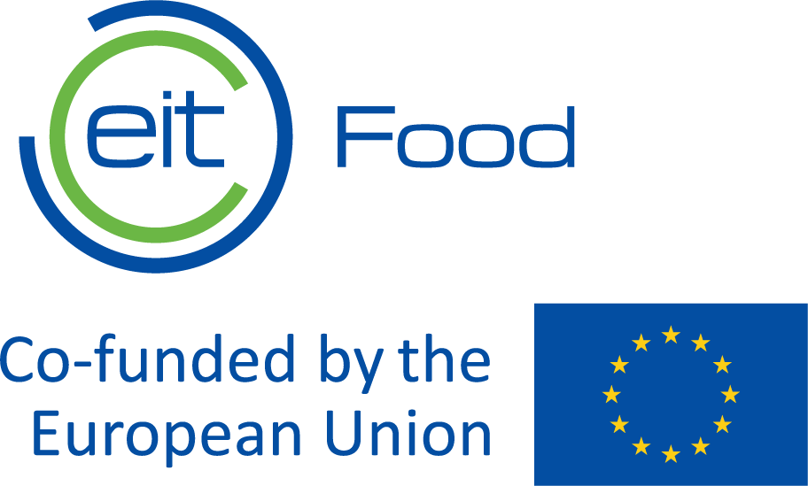
​RIS Straight to Market

Submission Document

Retailers

If you have any questions during the application process, please check the Call’s webpage or contact us at maria.canelhas@eitfood.eu
The Activity Leader is responsible for completing this submission form. Please read the Call Guidelines carefully.
I have read the Call Guidelines ☐

Individual Organisation (Consortium Member) Eligibility
Please complete the below table for each consortium member.
Name of the Activity Leader | Enter the Name of the Activity Leader
Activity Leader's organisation | Activity Leader's organisation
Email address of the Activity leader | Enter the email address of the Activity Leader.
Name of eligible EU or Horizon Europe country in which this organisation is a legally incorporated entity: | Enter country
Has this organisation been a legally incorporated entity in the stated country for a minimum of 3 years? | Yes/No
Can this organisation provide at least 3 years’ published accounts showing business Activity? | Yes/No
PIC # of Activity Leader´s Organisation (Learn about PIC # https://www.eitfood.eu/files/PIC-Guidance.pdf) | Enter the PIC # of the Activity Leader.
Legal form
Office address (street, city, country)
Website address
Contact person
Position
E-mail
Phone
Please highlight/indicate if your organization would be committed to work with only one or more than one start-up | Only one start-up
 | We can work with up to 4 start-ups (how many?)
List of documents fulfilled and signed
Application template | ☐
Business model canvas template | ☐
Gantt chart with implementation schedule for Project activities | ☐
Detailed budget breakdown | ☐
Commitment to co-fund 30% of total amount | ☐
Commitment to contribute to EIT Food’s Financial Return Mechanism | ☐

Consortium Eligibility
Are you applying in consortia with a startup? | Yes/No
Name of the startup organisation | Enter name of the organisation(s)
Does each member of the consortium have an active role that is commiserate with the level of budget asked? | Yes/No

Retailer Information (only if applying as consortium)
Please describe the ability of the retailer to bring a new product to the market, specifically:
- Capability and Capacity, including the company profile and sales experience
- Available infrastructure, organigramme, governance structure, staff roles and IT infrastructure
- Operational capability
- Experience of the exploiting partner in terms of product development and market launch
- Please describe the MRL (market readiness level) of the proposed product
Max 2000 Characters

Proposal Eligibility
Is the goal of this proposed activity to deliver one or more near-to-market, commercially viable innovative technology solutions (goods, services, processes, or products) within 18 months? | Yes/No
Please list which EIT Food Missions you commit to address by bringing to market the new product

Max 3000 characters

Please list which EIT Food Focus Areas you commit to address by bringing to market the new product
Max 3000 characters

Impact
Indicate how you will commercialise the new product and other relevant actions you will carry out in order to promote the new, healthier product developed by the start-up
Max 5000 characters

Please describe preferred product characteristics/innovative features, based on your own market segmentation, according to EIT Food’s Impact Framework goals described in Table 1 of the Call.
Max 3000 characters
Please provide examples of the relevant activities/services/projects implemented by your organisation that involved active support to small and medium-size companies (including start-ups) for the placement of new, innovative products in the market and justify, why they are meaningful for the Project.
Max 3000 characters
Please describe your company’s experiences in designing and introducing new types of food products, including your approaches to healthier and more sustainable products. Please refer to the scale of your operations (volumes of food packaging sold, composition of product portfolio, number of clients-food service providers, sales revenues).
Max 5000 characters

KPIs
Please insert the number you commit to achieve, and describe how you will deliver the following the mandatory KPIs for 2023. The feasibility of achieving the KPIS will be evaluated.

KPI reference | KPI title | KPI description | Target  date | Minimum  Target  Per project | Proposed for 2023
EITHE02.4-EITRIS | EIT RIS Marketed Innovations | Number of all innovations introduced on the market during the programme duration or within 1 year after completion. Innovations include new or significantly improved products (goods or services) sold.  Innovations introduced on the market must be directly linked with the programme and reported in the year when they reached the first revenue (but not later than one year after completion of the programme).  Sales revenue > 10KEUR | 30 June 2024 | 1
Max 5000 characters

EITHE11.1 | FS revenue | Total financing generated in year N (absolute value in EUR). | Up to 15 months after project official end date | According to FRM (section 3.5.3)
Max 5000 characters

EITHE16 | Disseminated results/GP/LL | Continuous dissemination by consortia: number of results, good practice (GP) and lessons learnt (LL) disseminated through appropriate means (e.g., publications, online repositories, fact sheets, targeted workshops). Results are any tangible or intangible output of the action, such as data, knowledge and information. | 1 December 2023 | 1
Max 5000 characters

EITHE17.1 | Reach of KIC’s communication activities: # media coverage | # media articles in the media (articles and broadcast in global / European / national / local press, TV, radio, etc). | 1 December  2023 | 5
Max 5000 characters

KIC01 | # People involved in interventions | Number people actively engaged in targeted interventions aimed at encouraging healthier and more sustainable behaviour | 1 December 2023 | 20
Max 5000 characters

Value Proposition
Please provide examples of involvement of your organisation in activities engaging consumers on healthy food and sustainable products
Max 5000 characters

Please describe the proposed the creative workshops with a group of consumers that could be meaningful for the Project and also beneficial for consumers in your country
Max 5000 characters

Please describe if/how you’re planning to work in collaboration with Academia/Research stakeholders during the development of the programme activities
Max 5000 characters

Please describe how you plan to promote the Projects in local media to ensure publications in the local language
Max 5000 characters

Risk analyses and mitigation plan
Please describe the potential risks of your project and respective mitigation plan to minimize them

Workplan & Deliverables
Programme timeline (indicate specific dates): Indicate the timeline proposed for the development of the necessary activities previous to launch the product (including certification of the product)
Max 3000 characters

Please attach a Gantt chart with implementation schedule for Project activities | Attached ☐

Financial Return Mechanism
What is the planned source of revenue from your Activity (ROI mechanism)?
Max 1000 characters
Estimated Contribution to EIT Food Financial Sustainability (amounts)
2023 | 2024 | 2025 | 2026 | 2027 | 2028
€ | € | € | € | € | €
Business Model Canvas | Attached ☐

Budget/Value for Money
EIT Food Contribution | 2023 | 2024 | 2025
Co-Financing
% Co-Financing
Equipment
% Equipment

Please attach the estimated total cost of the Activity and detailed budget breakdown per cost category and per project:  - Personnel Cost estimated amount and number of FTE foreseen  - Travel and subsistence cost estimated and brief justification  - Cost of other Goods and services estimated and brief justification  - Cost of equipment  - Other: specify the cost category and a brief description  Note: a full breakdown of costs may be requested if your proposal is selected. | Attached ☐
Budget justification (per year)
Max 6000 characters
Value for Money
1500 words

