2023 Innovation Call for Proposals

Criticality Map

EIT Food
19 August 2022

The criticality of each technology should be assessed by the consortium using the following scale 1 to 3:
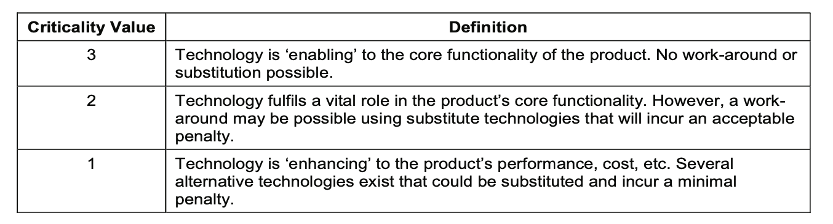
Field Name | Critical/Core Technology
Content Type | table
Help | Please indicate each individual critical/core technology composing the innovative solution.
Technology | TRL Level | Criticality Level (1/2/3) | Please justify the critical/core technology level according to the definition provided.  - You mentioned some technologies are critical, why?  - You mentioned some technologies are not critical, why?

